**Project: Student Database Management System (PostgreSQL)**

**1. Database Setup**

Create a database named "student_database."

Create a table called " student_table " with the following columns: Student_id (integer), Stu_name (text), Department (text), email_id (text), Phone_no (numeric), Address (text), Date_of_birth (date), Gender (text), Major (text), GPA (numeric), Grade (text) should be A,B,C etc.

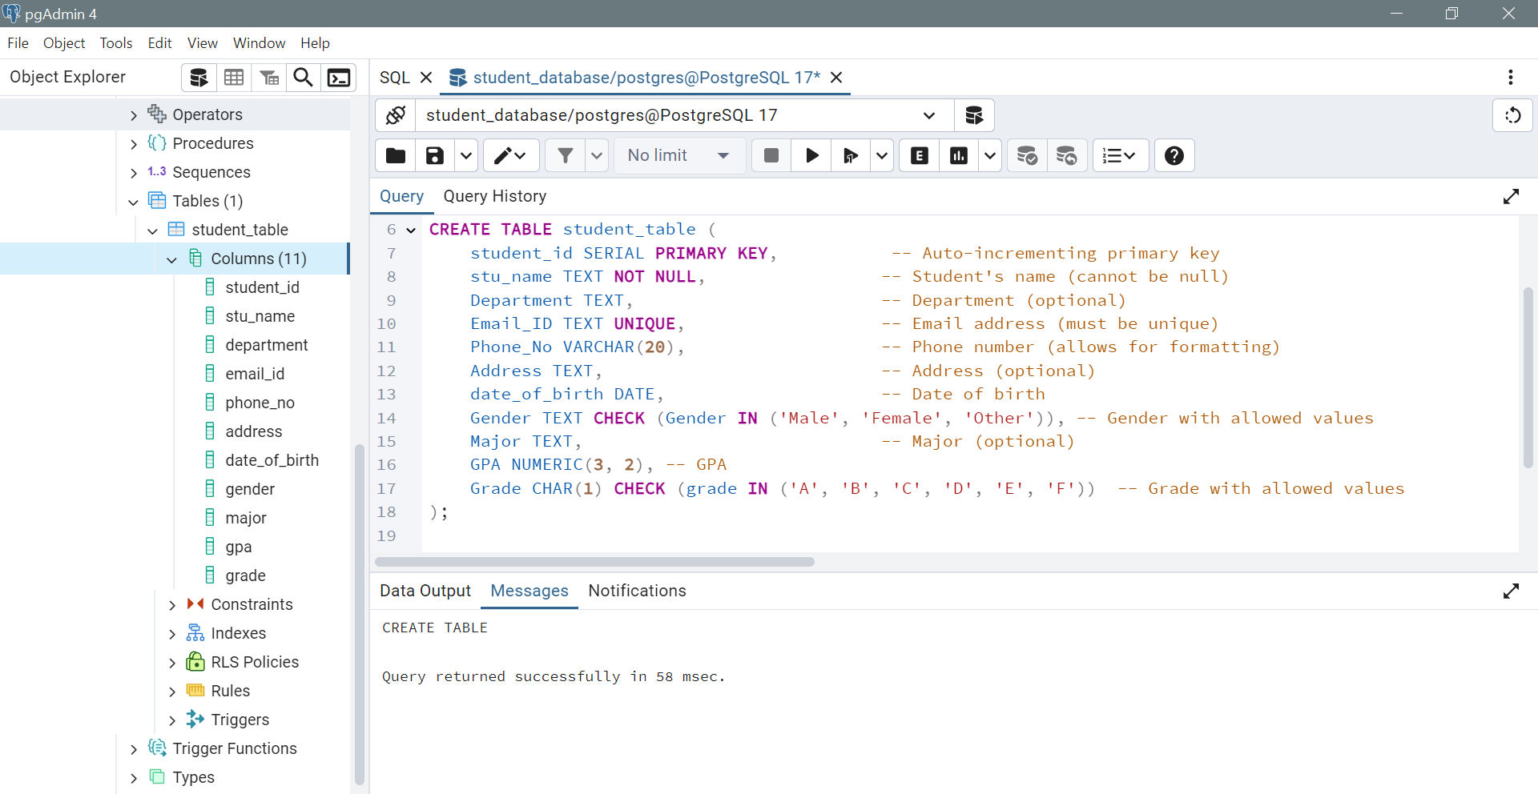

**2. Data Entry**

Insert 10 sample records into the "student_table" using INSERT command.

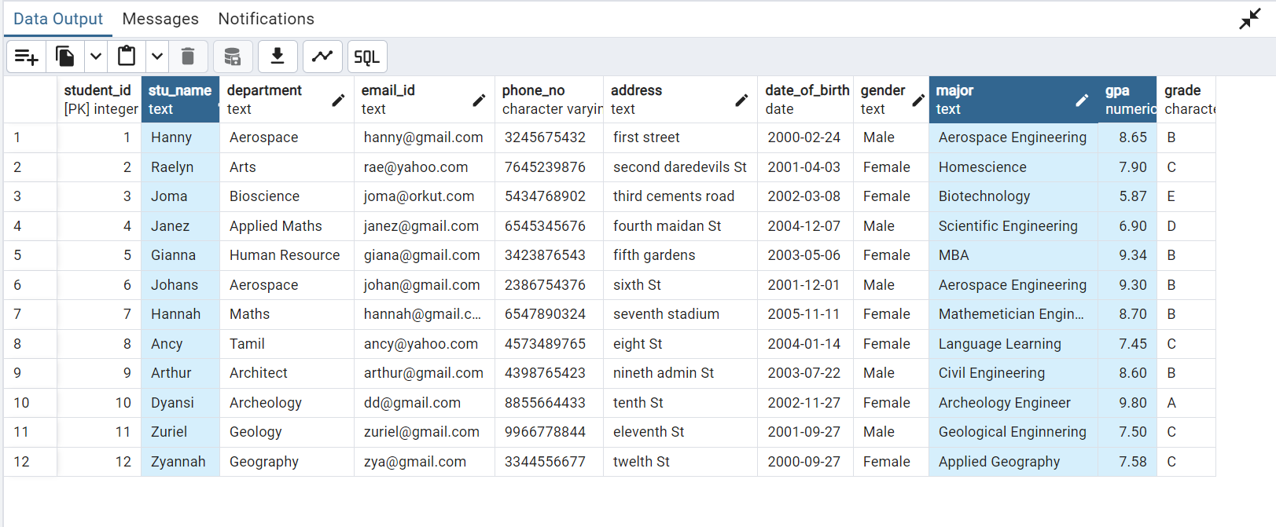

**3. Student Information Retrieval**

Develop a query to retrieve all students' information from the "student_table" and sort them in descending order by their grade.

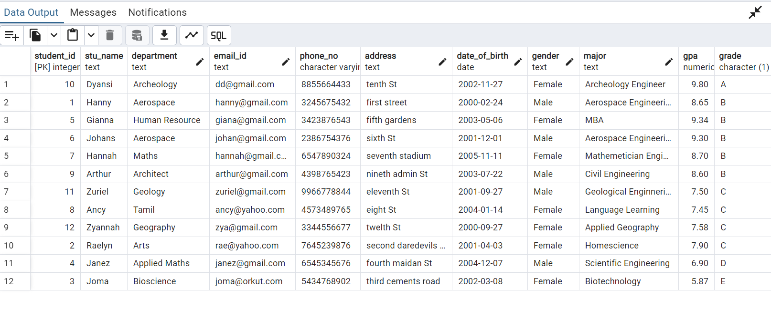

**4. Query for Male Students:**

Implement a query to retrieve information about all male students from the "student_table."

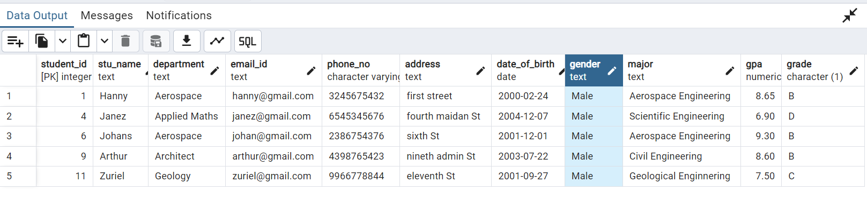

**5. Query for Students with GPA less than 5.0**

Create a query to fetch the details of students who have a GPA less than 5.0 from the "student_table."

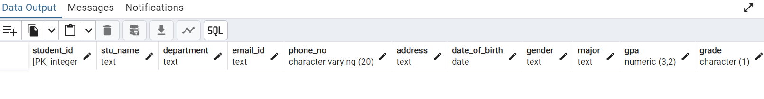

**6. Update Student Email and Grade**

Write an update statement to modify the email and grade of a student with a specific ID in the "student_table."

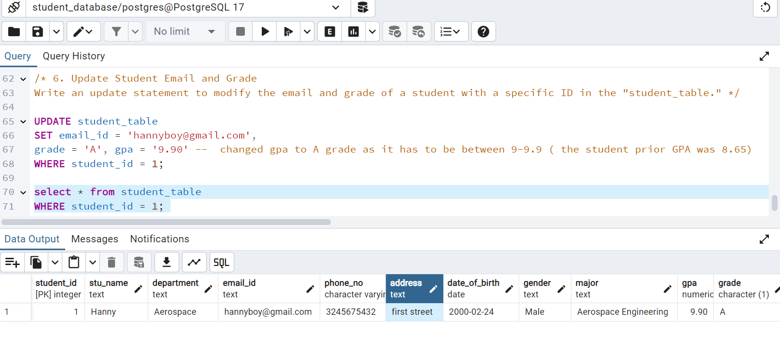

**7. Query for Students with Grade "B"**

Develop a query to retrieve the names and ages of all students who have a grade of "B" from the "student_table."

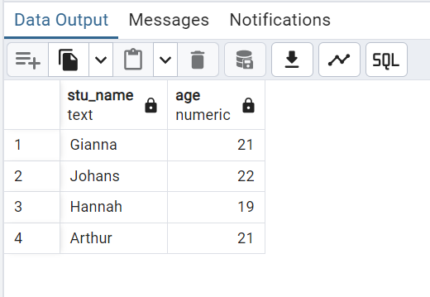

**8. Grouping and Calculation**

Create a query to group the "student_table" by the "Department" and "Gender" columns and calculate the average GPA for each combination.

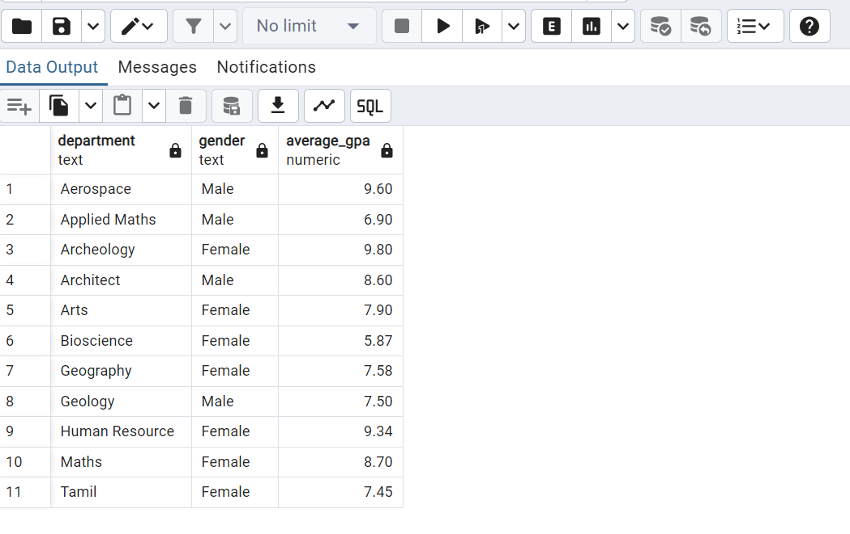

**9. Table Renaming**

Rename the "student_table" to "student_info" using the appropriate SQL statement.

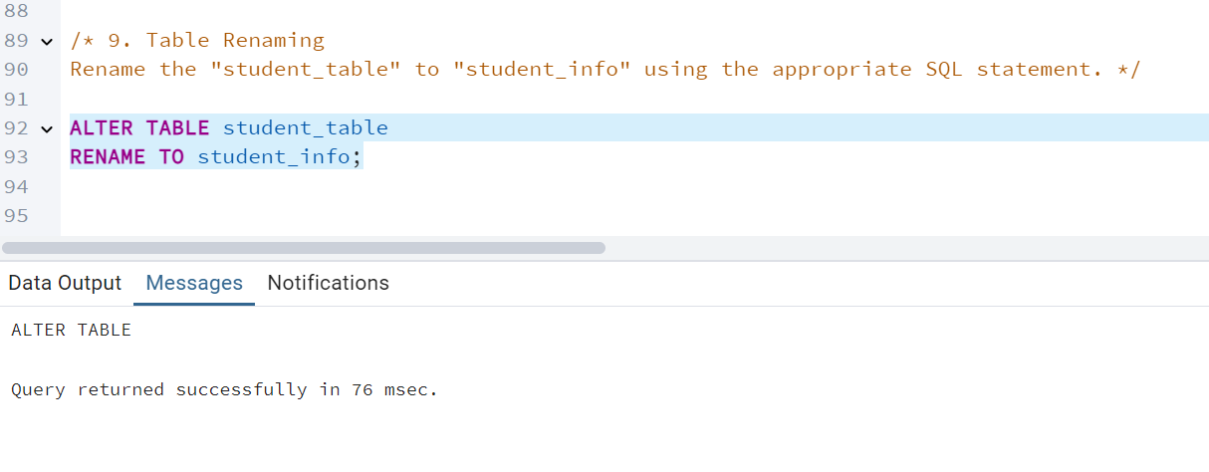

**10. Retrieve Student with Highest GPA**

Write a query to retrieve the name of the student with the highest GPA from the "student_info" table.

